Fitness – 7th Grade 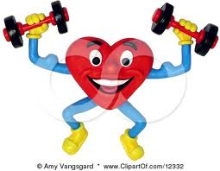

Students will value physical activity for health, enjoyment, challenge, self-expression, and/or social interaction.
(Standard #6)

Learning Objectives | I Can perform it | Still working on it | Don’t know how
1. I Can see recognize the positive connection between proper nutrition and exercise.

2. I Can recognize that effective fitness and activity program choices will vary among individuals.

3. I Can use activity participation to reduce stress.

4. I Can participate in activities that develop all elements of physical fitness.

5. I Can celebrate successes and achievements by self and others.

6. I Can participate in activities that are personally challenging and rewarding.

7. I Can identify appropriate risks in activity selection.

8. I Can appreciate how physical activity can provide social interaction among people of varying ability levels in team activities.

9. I Can understand the role of constructive criticism or feedback in learning.

Fitness Language students should know and use: | Stress, appropriate risks, social interaction

