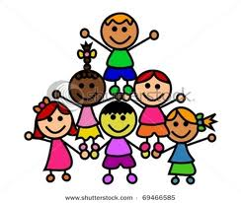 Fitness – 7th Grade 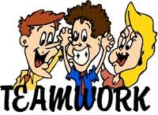

Students will exhibit responsible personal and social behaviors that show respect for themselves and others in physical activity settings. (Standard #5)

Learning Objectives | I Can perform it | Still working on it | Don’t know how
1. I Can make safe choices for self and others in operating equipment properly.
2. I Can consider consequences when confronted with a behavior choice.
3. I Can follow rules in activity participation.
4. I Can keep winning and losing in perspective.
5. I Can resolve interpersonal conflicts with empathy for rights and feeling of others.
6. I Can understand how to act independently of peer pressure.
7. I Can demonstrate the ability to follow as well as lead in activity settings.
8. I Can accept decisions of officials in a respectful manner.
9. I Can recognize the influence of peer pressure.
10. I Can participate respectfully and display sensitivity to the feelings of others while participating in activities with students of different abilities, gender, skills, and cultures.
11. I Can handle conflicts that arise with others without confrontation.

Fitness Language students should know and use: | consequences, perspective, interpersonal conflicts, empathy, peer pressure, confrontation

